DAROFF-DELL’OSSO OCULAR MOTILITY LABORATORY (DD_OMLAB)
LOUIS STOKES CLEVELAND DEPARTMENT OF VETERANS AFFAIRS MEDICAL CENTER
CASE School of Medicine
10701 East Boulevard Mail Code #151W
Cleveland, OH 44106, USA
Phone: (216) 421-3224
Fax: (216) 231-3461
Website: http://www.omlab.org
Note: Information from this page contains no medical advice.
You should always consult your doctor about INS treatments.
This document was created by Z. I. Wang and edited by Dr. L.F. Dell’Osso, 12/2007.
Note: In this document, we have presented very complex scientific information in laymen’s terms.

DD_OMLAB Patient Information Series:
4. NYSTAGMUS & VISUAL ACUITY

- What do Infantile Nystagmus Syndrome (INS) waveforms look like?
The illustration below contains some commonly seen Infantile Nystagmus [nĭ-STAG-muss] Syndrome (INS) waveforms. Usually a person with INS would have a combination of several waveforms, depending on the direction in which they are looking. For example, when they look right, they might have one waveform; when they look straight ahead, they might have another. Some people with a time-varying INS would have changing nystagmus waveforms even when they are looking at the same spot.

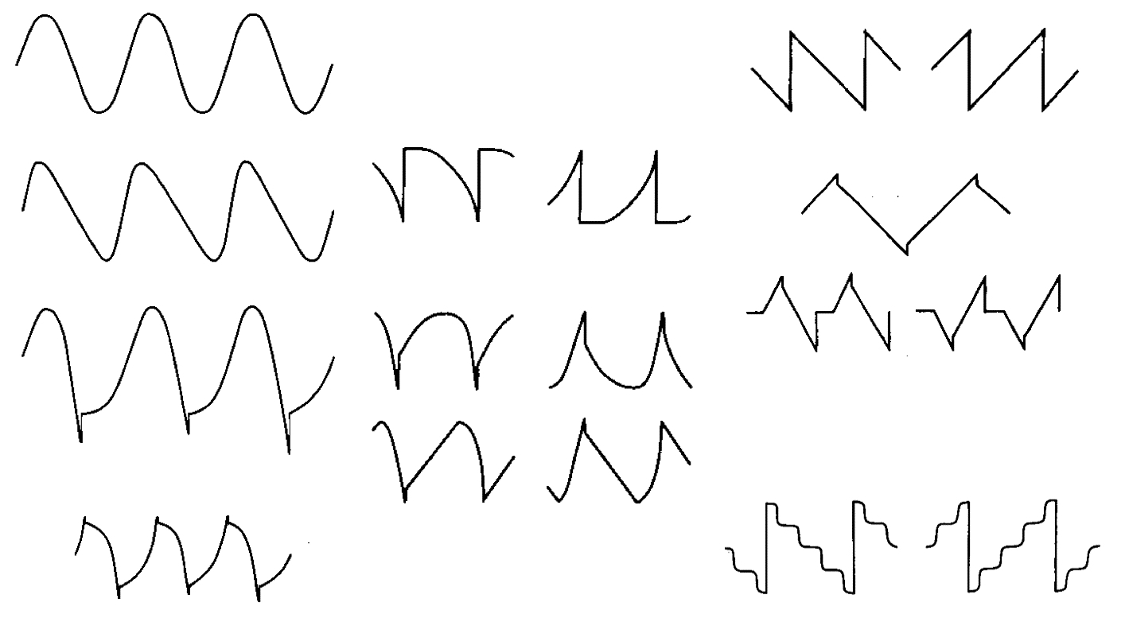
Eye-movement recordings can easily determine which waveforms an INS individual has, and how they change over different gaze angles and over time. This provides extremely important information for making a treatment plan.

Some of the names for nystagmus waveforms include: pendular, pendular with foveating saccades, pseudopendular with foveating saccades, jerk, jerk with extended foveation, dual jerk, and so on. Don’t be offended when you hear that you have “jerk” waveforms, it is only an engineering term to describe the waveform shape!

- How do INS waveforms determine visual acuity?
Basically, two factors are at play when determining the visual acuity in INS: the waveforms and the deficits in the visual system. If the visual system is perfectly OK and the only problem is the nystagmus, looking at the waveforms will predict the person’s visual acuity.
“Good” waveforms have long, aligned “foveation periods”. When you are looking at a target, the image of the target is held steady on the fovea, the part of the retina (the back of your eye) with the best possible vision. Your eye movements need to be steady for looking at details of the target. In the Figure below, the arrows are pointing to the relatively steady moments in the nystagmus cycles. It is only during these moments that people with nystagmus can see a stable world. The brain conveniently disregards the rest of the nystagmus cycle. The brain knows the visual information is the best during those steady moments, and makes use of that information! Scientifically, we call these moments “foveation periods”. The longer the “foveation periods” are, the better people see. In people without nystagmus, their eye position recording is always a straight line when they are staring at one spot. They can use all that visual information at any time.

So, take a guess on line 1 in the Figure: Does the waveform on the left or the right produce better vision? The answer is the left, because it has much longer “foveation periods” than the right.

In order to see well, you not only need long “foveation periods”, but also need these periods to be lined up well. Take a look at line 2 in the Figure; if the left and the right have the same amount of steady time, which one gives better vision? The left one is better because it is much more aligned (less jagged) than the right one! What about the line 3 in the Figure? Left is better than right because it is again much more aligned.

Could a large nystagmus have the same “foveation periods” as a small nystagmus? It is entirely possible! Look at line 4 in the Figure; they are equal in terms of “foveation”, although different in their actual sizes. It is also possible that a person with a large nystagmus has better “foveation” than a person with a small nystagmus (for example, line 1 in the Figure); you can’t judge by the size of the nystagmus, you have to look at the “foveation periods”– they are the only functional part of the waveform!

Only through eye-movement recordings can we accurately measure the “foveation periods” in INS. Everyone has a different set of waveforms. When determining if a nystagmus surgery has achieved a positive functional effect, we have to refer to the “foveation periods”, not just the cosmetic nystagmus size (that is, how big the wiggle is).
